Enhancement of productivity after reservoir stimulation of the hydro-thermal reservoir Gross Schönebeck with different fracturing concepts

Zimmermann, G., Huenges, H., Saadat, A., Legarth, B., Blöcher, G., Reinicke, A., Milsch, H., Holl, H.-G., Moeck, I., Köhler, S., Brandt, W.
GeoForschungsZentrum Potsdam
Telegrafenberg
D-14473 Potsdam, Germany
e-mail: zimm@gfz-potsdam.de

Abstract
A series of stimulation experiments were carried out at the well Groß Schönebeck, a geothermal research well in the north-eastern part of Germany. The aim was the development of concepts for the productivity enhancement of geothermal wells in that region. In a first attempt hydraulic proppant-gel fracturing treatments were conducted in two sedimentary reservoir zones with high permeability at about 4 km depth. These treatments were performed under challenging conditions in the open hole section at a temperature of about 150°C. They proved to be on the one hand technically demanding and on the other hand less successful than expected due to a suboptimal design. Most likely, the small injection volumes combined with a low proppant density did limit the success of these operations. Nevertheless, the productivity of the well could be increased by a factor of two. The characterisation of the inflow zones after the proppant fracs and derived values for the minimal horizontal stress led to a completely different frac concept. Massive waterfrac treatments were now applied over the entire open hole interval of the well below 3874 m to the final depth at 4294 m. Again, a significant increase of productivity was achieved, demonstrating that waterfracs can be a successful and effective stimulation concept for the geological situation. Evidence of the creation and properties of a very long vertical fracture were retrieved from pressure response analyses demonstrating a bilinear flow regime. The stimulation effect in terms of a productivity increase was determined for the described concepts and improvements are derived for similar field experiments.
Keywords: reservoir stimulation, hydro-thermal, waterfrac, gel-proppant frac

Introduction
Sustainable and environmentally friendly energy can be generated from the conversion of Earth’s heat (from formation fluids) into electricity. The preconditions for an economic generation of geothermal electricity are sufficiently high temperatures and flow rates of about 50 m³h⁻¹ and 150 °C (Köhler & Saadat, 2003).
The required temperature for this purpose can be found in the North German Basin in 4000 m to 5000 m. At this depth the initial permeability of the rocks is generally insufficient for the necessary flow rates. However, stimulation operations to improve the near wellbore regions can lead to a sufficient productivity increase.
Concepts have to be developed to enhance the existing flow. This can be summarized by the term hydraulic fracturing. During stimulation experiments fluids under high pressure penetrate into the rock and generate or extend fractures. These procedures are well known in hydrocarbon industry (e.g. Economides & Nolte, 1989) as well as in the Hot Dry Rock (HDR) technology (Hettkamp et al., 2004; Baumgärtner et al. 2004). However, the objective for using hydrothermal reservoirs requires a special stimulation technique to be able to produce considerable higher amounts of fluids compared to hydrocarbon reservoirs. In contrast to the HDR technology the aim was not to create an underground heat exchanger but to get access to formation fluids in the reservoir. The most important parameters in these experiments include fracture fluids volume, injection rate, viscosity (water with added polymers), the composition of chemical variants or added proppants, and the selection of the depth interval to initiate new fractures. In the following, we summarize the stimulation experiments carried out over the recent years in the well Groß Schönebeck 3/90. A detailed description of the work presented here is in the process of publication (Zimmermann et al., 2006).

Initial reservoir conditions
The former gas well Groß Schönebeck 3/90 drilled in 1990 was re-opened and deepened to 4294 m at the end of the year 2000 to get access to the Rotliegend formation. The well encounters the typical sequence of various geological formations known in the North German Basin. A series of 2370 m of Quarternary to Triassic sediments is under lain by 1492 m of the Zechstein salinar. The following section of this well, which was foreseen for testing, comprises 400 m of Rotliegend formation (siltstones, sandstones, conglomerates and 60 m of underlying volcanic rocks) up to the final depth of 4294 m (Huenges et al., 2002; Holl et al., 2004). This section below 3874 m was an open-hole section at times of the intended stimulation treatments of the well with access to the reservoir rocks. In 2003 this section had to be cased with a perforated liner due to instabilities of the borehole wall in the siltstone layers. During this treatment the well was deepened to 4309 m and reached the top of the carbon.
The initial hydraulic condition of the well was tested with a casing lift test in January 2001 over the whole open hole section between 3874 m to 4294 m. During the test a total volume of approximately 167 m³ of fluid was extracted over 12.3 hours with an average flow rate of 13.5 m³/h and a maximum pressure draw down of 14 MPa. Hence, the resulting productivity index achieved 0.97 m³/(h MPa) at maximum pressure drawdown. Subsequently, a flow log was run which showed outflow of the conglomerates and the volcanic sequences of the reservoir (Fig. 1). The rocks of the Rotliegend Sandstones intended for use as the geothermal reservoir were totally blocked (Huenges et al., 2002; Zimmermann et al., 2003). The reason for this blockade is believed to be the mud infiltration during the long standstill period of approximately 10 years. Permeability measurements on cores from the well showed mean values of 10⁻¹⁴ m² (10 mD) and documented the general usability of these reservoir rocks (Trautwein, 2005; Trautwein & Huenges, 2005).
Transmissibility was calculated from the shut-in period of the initial test and estimated to 4 – 6 x 10⁻¹⁴ m³ (0.04 – 0.06 Dm). Due to the short time of production no stable conditions can be assumed and hence the determined transmissibility is only a rough estimate of the close borehole conditions.
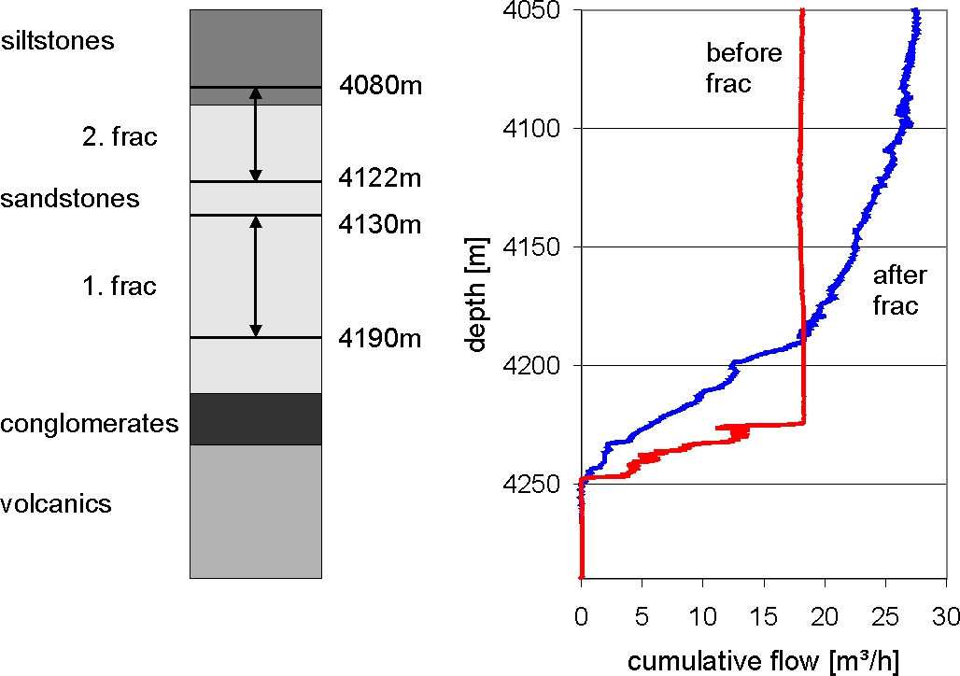
Figure 1. Left side: frac intervals during the stimulation treatments in 2002; right side: cumulative flow before and after the frac treatments.

Stimulation treatments

Sandstone stimulation
The first stimulation experiments were of conventional kind, i.e. on the basis of expertise of the hydrocarbon industry. Two experiments were performed in January 2002 using proppant-gel-frac techniques in two intervals of the Rotliegend sandstones (Fig. 1) (Zimmermann et al., 2003; Legarth et al., 2005). Experimental design comprised the isolation of the bottom boundary of the interval of interest by filling the bottom of the well with sand. The top of the interval was sealed with a mechanical packer. High viscosity fluid (gel) with proppant was employed for stimulation. The flowmeter-log indicated a significant increase of inflow due to this frac operation (Fig. 1). Visualisation by Borehole Televiewer (BHTV) and Formation Micro Imager (FMI) confirmed the creation of an open vertical fracture with a height of more than 100 m and in the direction of the maximum horizontal stress (S_{H} = 18.5° ± 3.7°) (Holl et al., 2003; 2004). Nevertheless the observed flow rates were not sufficient for economic power production (Zimmermann et al., 2003), but the productivity index could be enhanced to 2.2 m³/(h MPa) due to the stimulation treatments. The mean flow rate obtained during the casing lift test was 22.4 m³/h at a differential pressure of 10.5 MPa at the end of the test. A total volume of 307 m³ was produced at the duration of the test of about 14 hours, which is a similar time of production as during the previous casing lift test. Hence this result can be compared to the previous test indicating a doubling of the productivity index of the well. Legarth et al. (2003) conclude that the limited achievement was strongly influenced by the proppant properties during the treatment and prevented a better result of the stimulation treatments.

Massive waterfrac treatment
The first treatment started in January 2003 with a moderate injection test with a flow rate of 3.6 m³/h over a period of 200 hours. The aim of this pre-test was to obtain initial injection properties of the reservoir and to compare these results with the former short term and long term production tests carried out in spring and summer 2002. After 48 hours the injectivity index was 1.15 m³/(h MPa) and decreased to 0.83 m³/(h MPa) at the end of the test after 200 hours (Tischner, 2004). The observed injectivity corresponds to the productivity derived in former production tests at similar low differential pressure. For this reason it can be assumed that the hydraulic response of the reservoir is similar for production and injection for a pressure change up to 10 MPa (decreasing for injection as well as increasing for production).
Thereafter, the first massive waterfrac treatment was performed in whose progression a total amount of 4284 m³ fluid was injected under high pressure into the reservoir. In the first part a pressure step test with gradually increasing injection rates up to 24 l s⁻¹ was performed. The results show that starting with an injection rate of 8 l s⁻¹ the pressure increase is reduced due to an enhanced injectivity of the formation. This effect can be interpreted as a mechanical reaction of the rock due to an opening of the existing generated artificial fractures as well as the extension of pre-existing fracture in the conglomerates and volcanic rocks at the bottom of the well (Huenges et al., 2006).
In a subsequent flow back test 250 m³ of water was produced within a time of 5 hours and a mean flow rate of 50 m³/h. This indicates in comparison with tests after the sandstone frac treatment a significant increase of productivity. Productivity index is above 4 m³/(h MPa) during the whole test. This is an indication that the massive water injection produced additional fractures, so that the experiment was rated successful and represented roughly another doubling of the productivity index. However, borehole breakouts occurred resulting in an obstruction just at the upper part of the tested section at about 3900 m depth. Therefore, further technical borehole operations were necessary. In October 2003 the obstruction in the well was removed and the well was deepened to 4309 m and an additional liner from 3850 m down to the final depth was installed. Prior to the liner installation, an extensive logging program was performed in order to get information about the geological structure and the lithology of the borehole section of interest. The liner was installed with perforated tubes in the lower part beneath 4135 m installation depth (diameter of holes 15 mm; 93 holes per metre circumferential) to ensure the hydraulic contact to the formation. In the stabilized well the massive water frac experiment was continued in fall 2003 (Fig. 2).
The massive injection treatment was continued with a pressure step rate test to obtain the fracture opening pressure (Huenges et al., 2005). Thereafter, a massive stimulation test of 30 ls⁻¹ to 40 ls⁻¹ over several days and one short peak of up to 80 ls⁻¹ for approximately 2 minutes were performed. The total injection volume accumulated to 7291 m³. Initially, it was intended to perform the last high rate flow injection over 8 hours, but due to a cable break during the first few minutes the test had to be abandoned. The pressure step rate test indicates multiple fracture opening events. Fracture closure pressure was determined by pressure decline analyses during shut-in at 6.4 MPa above formation pressure. According to model calculation (Legarth et al., 2005) the pressure data of the stimulation treatment demonstrated the existence of an artificial fracture. Assuming one single vertical fracture, it spans vertically over a height of 120 m in north-south direction and extends horizontally at least 160 m into the formation. The mean fracture aperture is in the range of approximately 5mm during the stimulation treatment at an injecting flow rate of 30 l/s.
Within a 24 hours flow back test 859 m³ water was produced back from the formation indicating another increase of productivity in comparison with former tests. Due to the cable break and loss into the well the pressure response is affected by frictional loss. After the cable loss a step down test was performed. This pressure response can be used to correct the frictional effects. This non linear effect is potentially turbulent flow due to the resistance of the cable above the open hole section of the well. This quadratic behaviour of flow versus pressure was applied to obtain undisturbed pressure values in the subsequent flow back test. The results show that the stimulation treatments yielded an increase of productivity up to 14 m³/(h MPa) determined at fracture closure pressure. The productivity index decreases with decreasing differential pressure giving a clear indication of a closing fracture. Hence it can be concluded that a self propping effect is nonexistent for the fractures of the Rotliegend sandstones and only a residual fracture conductivity remains. At the end of stable flow conditions at a flow rate of 50 m³/h the remaining productivity index is 7.5 m³/(h MPa), which corresponds nearly to another doubling.

max.
80 l/s
500 bar
Figure 2. Casing profile of the massive water frac treatment. Access to the reservoir is given through the pre-perforated liner at the bottom.

The pressure response of the flow-back test reveals a clear indication of a bilinear flow signature (p ~ t^{0.25} ; according to Cinco-Ley & Samaniego-V., 1981) during the first part of the test (Tischner, 2004). At the end of the injection and especially at the end of the shut-in the pressure signature shows a pseudo radial flow response (p ~ ln t; e.g. Horne, 1995).
Fracture conductivity was calculated according to the bilinear flow analysis to 0.4 Dm, the fracture half length is 142 m. From pseudo radial flow phase the maximum transmissibility was estimated to 0.065 Dm from curve fitting (Tischner, 2004).

Interpretation of stimulation operations
The initial production test before stimulation showed inflow only from the volcanic rock section of the reservoir. Since these rocks only have negligible matrix permeability this inflow is due to natural fractures of the volcanic rocks. The sandstone layers were totally blocked.
After stimulation treatments of the sandstones the flow log showed a clear indication of additional inflow from the sandstones. Furthermore the productivity index had increased. At low differential pressure the situation is different: the inflow from the sandstones decreases and the artificial fractures close. Hence the productivity index is similar to that of the initial situation. This interpretation is supported by the determination of the associated transmissibility before and after stimulation, which shows similar values. Transmissibility was calculated in each case from the shut-in after the production test and represents a value at low differential pressure.
The massive waterfrac treatments were performed in the whole open section of the well which included the sandstone layers and the volcanic rocks. These treatments led to an additional access to the sandstone intervals and the volcanic rocks in the vicinity of the borehole due to the generation of additional artificial fractures.
After these waterfrac treatments the effect in the sandstones is twofold: at high differential pressure the artificial fractures give access to the sandstone reservoir with a corresponding fracture half length of approximately 150 m. This leads to an additional increase in productivity index at high differential pressure and hence enables the access to the reservoir. At low differential pressure the fracture half lengths and the fracture apertures are reduced, so most parts of the fractures are not effective and the connection to the reservoir is blocked again.
This interpretation is supported by the results of a temperature log during a production test, which shows a clear indication of inflow from the bottom of the open hole section of the well (Fig. 3). Due to the obstruction below 4260 m the measured bottom of the interval was limited to 4255 m. The most significant change in the temperature profile and hence the most productive inflow was detected from 4212 m to the bottom at 4255 m yielding an effective inflow interval of 43 m. The limitation of this inflow to the conglomerates reveals that the contribution of the fractured intervals of the sandstone layers due to the proppant frac treatment can almost be neglected at low differential pressures, i.e. the artificial sandstone fractures are closed at these conditions.
Only in the near vicinity of the well the fractures are effective and improve the access to the borehole. But this is only a skin reduction and is limited to the near borehole environment and hence does not transcend the blockage of the sandstone reservoir.
Figure 3. Temperature profile of the open hole section during a production test.

In the conglomerates and the volcanic rocks at the bottom of the well new additional fractures were created. At low differential pressure only these sections give a contribution to the transmissibility. According to the low matrix permeability of these rocks this contribution is low and only the fracture system with a calculated extension of approximately 300 m is effective.
The transmissibility of the whole open hole section including the sandstones and the volcanic rocks has not changed substantially after all these fracture treatments and hence this is a further confirmation of the closure of the stimulated sandstone layers and a still existing blockade in the vicinity of the well at low differential pressure.

Conclusion
Development of a technology to stimulate deep geothermal reservoirs in sedimentary basins is the purpose of installing the down-hole geothermal laboratory in the former gas exploration well in Groß Schönebeck 3/90.
The results reflect the learning curve from several reservoir treatments. These experiments are major steps towards developing a procedure to increase the thermal water productivity from a prior low permeable sedimentary reservoir. For “engineering” this kind of reservoir type we recommend a method of massive waterfrac with a proppant treatment at the end to ensure 1) connection to the reservoir by generating long fractures and increasing overall transmissibility 2) tie-back of generated fracture system to the well 3) sustaining fracture conductivity by proppant placement.
The obtained values of productivity seem to show the feasibility of geothermal power production from a sedimentary geothermal reservoir. The concept for power production from the Groß Schönebeck reservoir comprises a doublet of wells. The second well should be completed as a production well. The existing well can be used as an injection well.

References
Baumgärtner, J., Jung R., Hettkamp, T. & Teza, D., 2004. The Status of the Hot Dry Rock Scientific Power Plant at Soultz-sous-Forêts, Z. Angew. Geol., Vol. 2, 12-16.
Cinco-Ley, H., Samaniego-V, F., 1981. Transient Pressure Analysis for Fractured Wells, Journal of Petroleum Technology, 1749-1766.
Economides, M.J., Nolte, K.G., 1989. Reservoir Stimulation, 2nd edn, Schlumberger Educational Services, Houston, Texas.
Hettkamp, T., Baumgärtner, J., Baria, R., Gerard, A., Gandy, T., Michelet, S., Teza, D., 2004. Electricity Production from Hot Rocks, Proc. 29th Workshop on Geothermal Reservoir Engineering, Stanford University, Stanford, California, January 26-28, 2004 SGP-TR-175.
Holl, H.-G., Hurter, S., Saadat, A., Köhler, S., Wolfgramm, M., Zimmermann, G., Trautwein, U. Winter, H., Legarth, B. & Huenges, E., 2003. First hand experience in a second hand borehole: Hydraulic experiments and scaling in the geothermal well Groß Schönebeck after reopening, Proceedings of the International Geothermal Conference, IGC-2003 Reykjavik, Multiple integrated uses of geothermal resources, S01, paper 060, 8-13.
Holl, H.-G., Moeck, I., Schandelmeier, H., 2004. Geothermal well Groß Schönebeck 3/90: A low enthalpy reservoir (Rotliegend, NE Germany), Proceedings 66th EAGE Conference & Exhibition, F032, Paris.
Horne, R.N., 1995. Modern Well Test Analysis, 2nd edn, Petroway Inc., Palo Alto, California.
Huenges, E., Hurter, S., 2002. In-situ Geothermielabor Groß Schönebeck 2000/2001, Scientific Technical Report, GeoForschungsZentrum Potsdam, STR02/14.
Huenges, E., Hurter, S., Saadat, A., Köhler, S., Trautwein, U., 2002. The in-situ geothermal laboratory Groß Schönebeck: learning to use low permeability aquifers for geothermal power, Proc. Twenty-Seventh Workshop on Geothermal Reservoir Engineering, Stanford University, Stanford, California, January 28-30, 2002, SGP-TR-171.
Huenges, E., Trautwein, U., Legarth, B., Zimmermann, G., 2006. Fluid pressure Variation in a Sedimentary Geothermal Reservoir in the North German Basin: Case Study Groß Schönebeck, Pure and Applied Geophysics, in press
Köhler, S., Saadat, A., 2003. Thermodynamic Modeling of Binary Cycles – Looking for Best Case Scenarios, Proceedings of the International Geothermal Conference, IGC-2003 Reykjavik, Multiple integrated uses of geothermal resources, S01, Paper061, 14-19.
Legarth, B., Huenges, E., Zimmermann, G., 2005. Hydraulic Fracturing in Sedimentary Geothermal Reservoirs, International Journal of Rock Mechanics and Mininig Sciences, Vol. 42, 7-8, 1028-1041.
Legarth B., Tischner, T., Huenges, E., 2003. Stimulation experiments in sedimentary, low-enthalpy reservoirs for geothermal power generation, Germany, Geothermics, Vol. 32, 4-6, 487-495.
Tischner, T., 2004. Stimulationsexperimente und hydraulische Untersuchungen in den Vulkaniten der Bohrung Groß Schönebeck, Abschlussbericht, Bundesanstalt für Geowissenschaften und Rohstoffe, Hannover.
Trautwein, U., 2005. Poroelastische Verformung und petrophysikalische Eigenschaften von Rotliegend Sandsteinen, PhD thesis, Technische Universität Berlin.
Trautwein, U., Huenges, E., 2005. Poroelastic behaviour of physical properties in Rotliegend sandstones under uniaxial strain, International Journal of Rock Mechanics and Mining Sciences, Vol. 42, 7-8, 924-932.
Zimmermann G., Hurter, S., Saadat, A., Köhler, S., Trautwein, U., Holl, H.-G., Wolfgramm, M., Winter, H., Legarth, B., Huenges, E., 2003. The in-situ geothermal laboratory Groß Schönebeck- stimulation experiments of sandstones in 4200 m depth, Proc. Twenty- Eight Workshop on Geothermal Reservoir Engineering, Stanford University, Stanford, California, SGP-TR-173.
Zimmermann, G., Tischner, T., Legarth, B., Huenges, E.; 2006. Enhancement of productivity due to stimulation of a hydro-thermal reservoir with different fracturing concepts, Geophys. J. Int., submitted

